Petition for Initiation and Membership

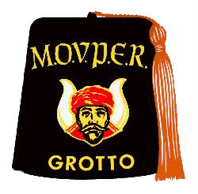
MOHASSAN GROTTO

Mystic Order of Veiled Prophets
Of The
Enchanted Realm

To the Monarch and Prophets of Mohassan Grotto:
The subscriber respectfully represents that he is a Master Mason in good standing and wishes to offer himself as a candidate for the mysteries of the Veiled Prophets of the Enchanted Realm and if found eligible, promises to cheerfully conform to all the established usages, customs and regulations of the Order and to the Bi-Laws of Mohassan Grotto.

PRINT YOUR NAME IN FULL

What is your age: ______________ Date of Birth: ________________________________________________

Where Born: ____________________________________ State of: __________________________________

Where do you reside: ________________________________________________________________________

Address where communications shall be sent: ____________________________________________________

City: ________________________________ State: ________________________ Zip: ___________________

Home Phone: _____________________ Cell Phone: ____________________ Email: _____________________

Name and No. of Lodge: _____________________________________ Located in: _____________________

What is your occupation: _____________________________________________________________________

Name and Address of Business: ________________________________________________________________

How long have you lived in the State: ___________________________________________________________

How long in city and town where you reside: _____________________________________________________

Size of hat: ________________________________________________________________________________

Have you ever, to your knowledge or belief, presented a petition to, or been rejected from any
Grotto of Veiled Prophets: ____________________ If so, what Grotto:_________________________________

Have you ever been convicted of a felony: ________________________________________________________

__________________________________________________________________________________Petitioner
PLEASE SIGN YOUR GIVEN FULL NAME AND WRITE PLAINLY – NO INITIALS PLEASE

FEE FOR ORDER MUST ACCOMPANY THIS PETION - $50.00 OR $150.00 WITH FEZ

